Tags
Thread tagging is a system that allows user to apply their own keywords (tags) to threads. See Wikipedia for more information on the ideas behind tagging. This can allow users to categorize threads based on the actual content. As such, if used consistently, could be a better way to find a specific topic than a full-text search.

Tags can contain any character except a comma, which is used to separate multiple tags. Additionally, you may not create tags which:
- Have less than an admin-specified amount of characters. The default is 3.
- Have over 25 characters. (This is the default value. You may change it by changing the "Tag Maximum Length" option.)
- Contain any censored words.
- Are in a list of common words.
This page allows you to manage the existing tags:
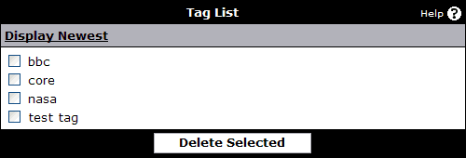
By default, tags are shown alphabetically and paginated. If you wish to see what tags have been added recently, you can click the Display Newest link.

Below this, you can add a new tag:
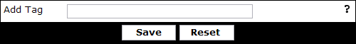
You may not add any invalid tags, as people will not be able to assign them to threads. See above for the tag rules.

